**B_18_DAYAL ADITYA KISHOR**

**Assignment No. 2**

**Title:**

Implementation of DML commands of SQL with suitable examples

* Insert
* Update
* Delete

**Problem Statement:**

Create tables in ORACLE using SQL DDL statements  
Sailor(sid:integer, sname:string, rating:integer, age:real)  
Boat(bid:integer, bname:string, color:integer)  
Reserves(sid:integer, bid:integer, day:date)

1. Insert following records in the above tables  
   Sailors

|  |  |  |  |
| --- | --- | --- | --- |
| sid | sname | rating | age |
| 22 | Dustin | 7 | 45.0 |
| 29 | Brutus | 1 | 33.0 |
| 31 | Lubber | 8 | 55.5 |
| 32 | Andy | 8 | 25.5 |
| 58 | Rusty | 10 | 35.0 |
| 64 | Horatio | 7 | 35.0 |
| 71 | Zorba | 10 | 16.0 |
| 74 | Horatio | 9 | 35.0 |
| 85 | Art | 3 | 25.5 |
| 95 | Bob | 3 | 63.5 |

Boat

|  |  |  |
| --- | --- | --- |
| bid | bname | color |
| 101 | Interlake | Blue |
| 102 | Interlake | Red |
| 103 | Clipper | green |
| 104 | Marine | red |

Reserves

|  |  |  |
| --- | --- | --- |
| sid | bid | day |
| 22 | 101 | 10/10/98 |
| 22 | 102 | 10/10/98 |
| 22 | 103 | 10/8/98 |
| 22 | 104 | 10/7/98 |
| 31 | 102 | 11/10/98 |
| 31 | 103 | 11/6/98 |
| 31 | 104 | 12/12/98 |
| 64 | 101 | 9/5/98 |
| 64 | 102 | 9/8/98 |
| 74 | 103 | 9/8/98 |

1. Find the name and age of all sailors
2. Find all sailors with a rating above 7
3. Increase rating of sailors by 10% whose age is less than 40
4. Update rating of all sailors by 2 who have reserved boat on 11/12/98
5. Delete sailors whose rating is less than 3 and age is above 60
6. Delete names of sailors who have reserved boat 102

Answers :

1.

create table Sailor(Sid int primary key,Sname varchar(20),rating int,age real);

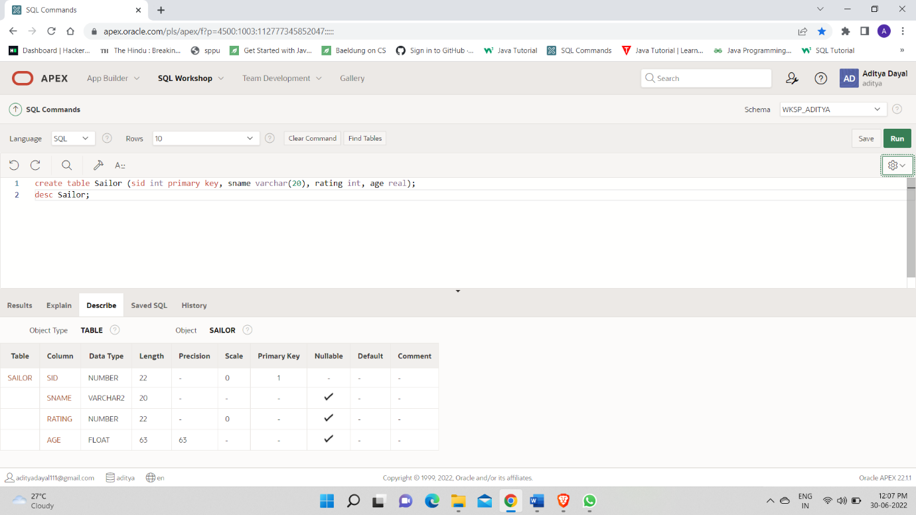

create table Boat ( bid int primary key, bname varchar(20), color varchar(20));

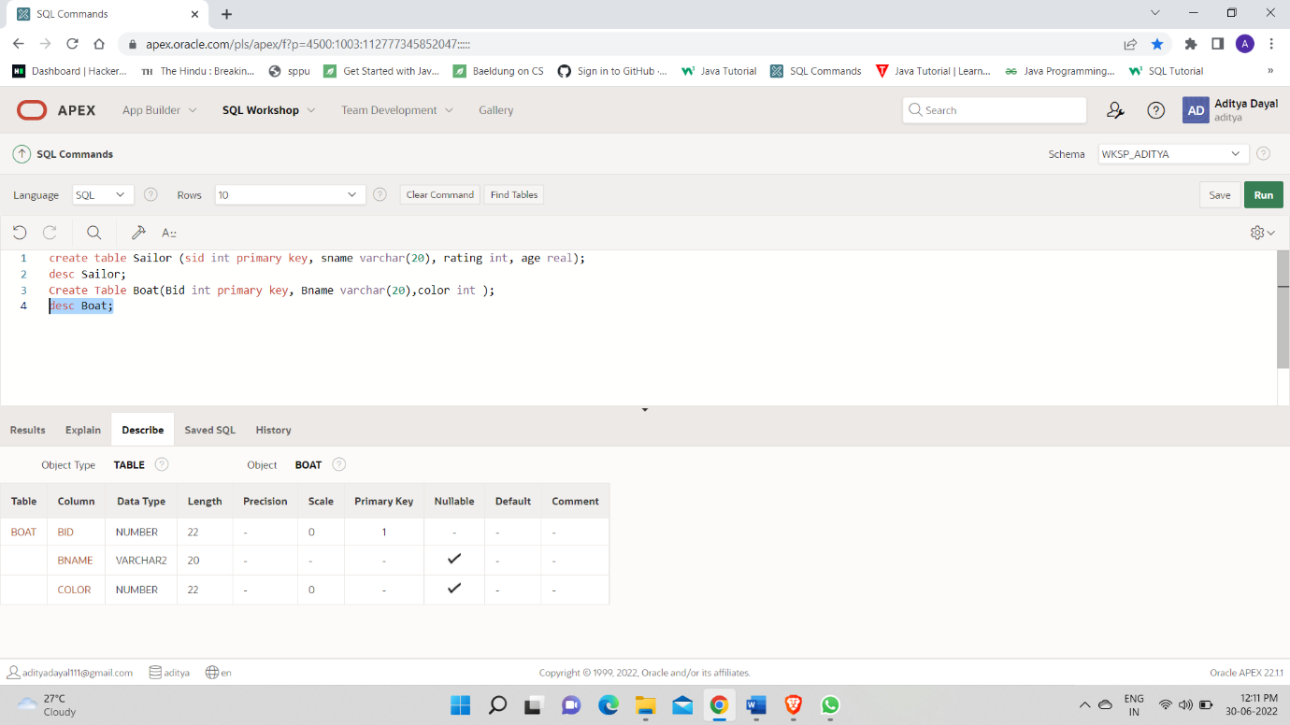

create table Reserves(sid int, bid int, day date, foreign key(sid) references Sailor1(sid) on delete cascade,foreign key(bid) references Boat(bid) on delete cascade);

desc Reserves;

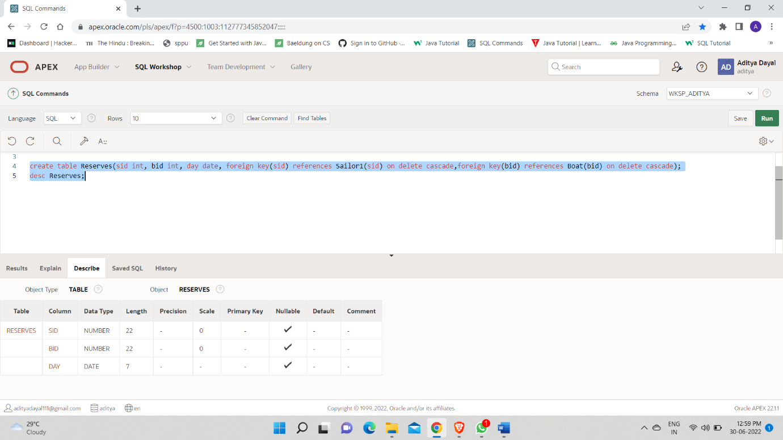

1.

insert into Sailor1 values ( 22, 'Dustin', 7, 45.0 );

insert into Sailor1 values ( 29, 'Brutus', 1, 33.0 );

insert into Sailor1 values ( 31, 'Lubber', 8, 55.5 );

insert into Sailor1 values ( 32, 'Andy', 8,25.5 );

insert into Sailor1 values ( 58, 'Rusty', 10, 35.0 );

insert into Sailor1 values ( 64, 'Horatio', 7, 35.0 );

insert into Sailor1 values ( 71, 'Zorba', 10, 16.0 );

insert into Sailor1 values ( 74, 'Horatio', 9, 35.0 );

insert into Sailor1 values ( 85, 'Art', 3, 25.5 );

insert into Sailor1 values ( 95, 'Bob', 3, 63.5 );

Select * from Sailor1;

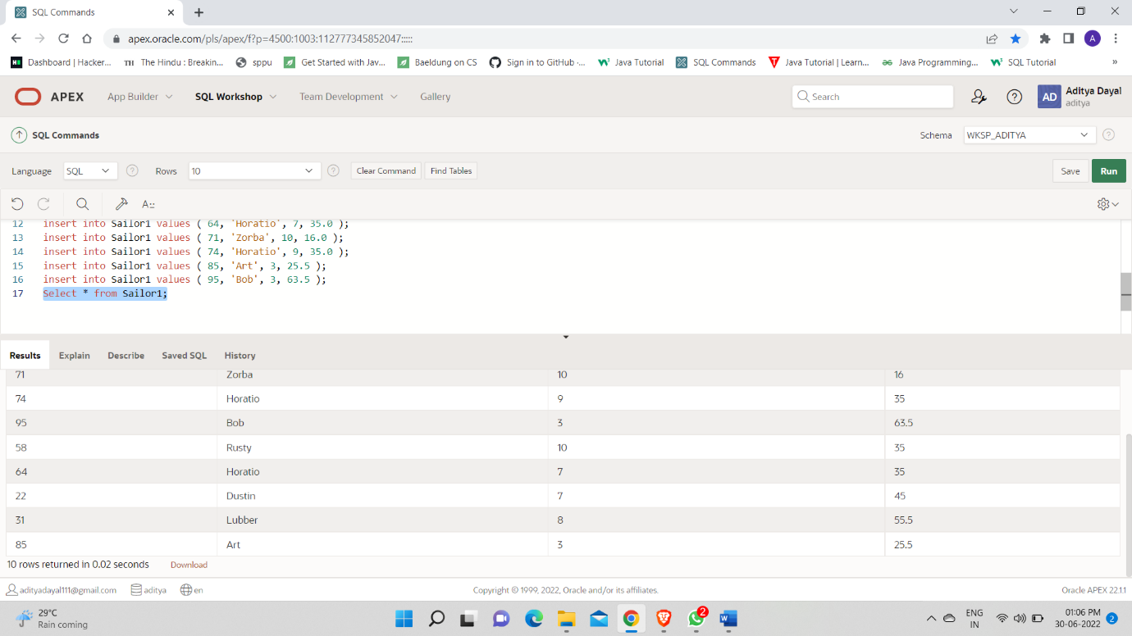

insert into Boat values(101,'Interlake', 'blue');

insert into Boat values(102,'Interlake', 'red');

insert into Boat values(103,'Clipper', 'green');

insert into Boat values(104,'Marine', 'red');

Select *From Boat;

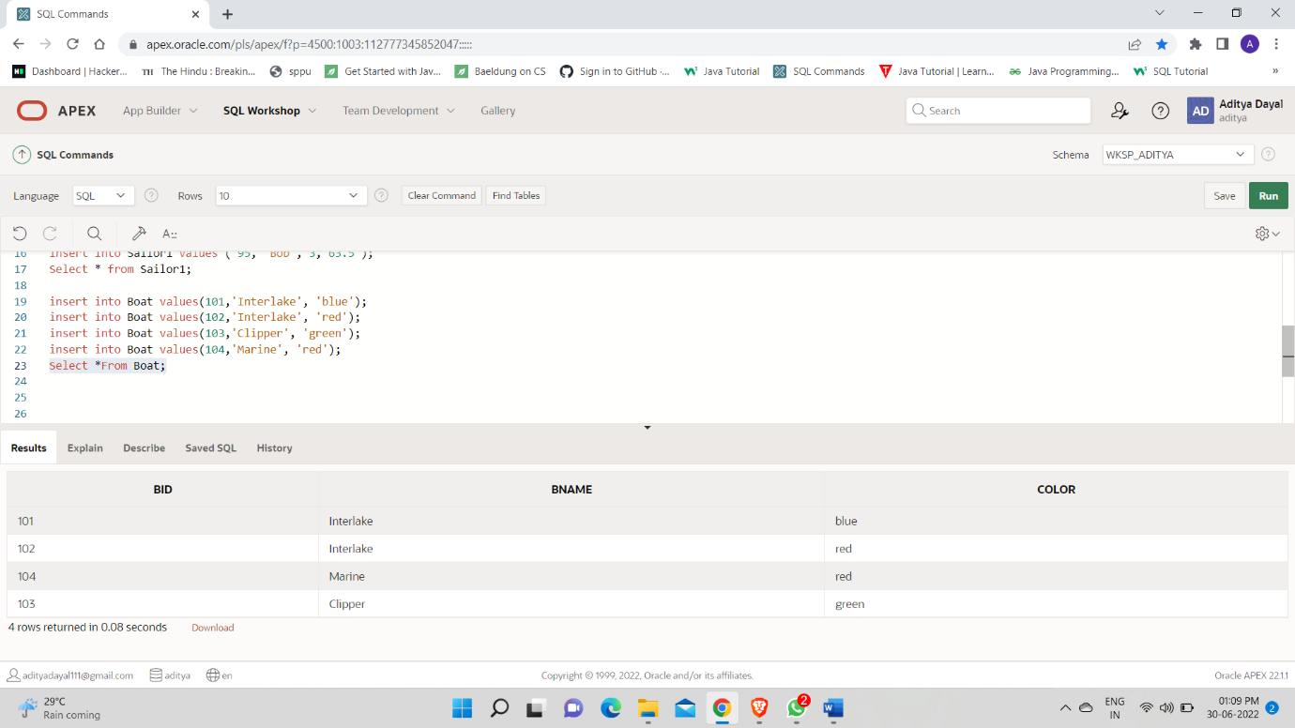

insert into Reserves values(22,101,'10/10/1998');

insert into Reserves values(22,102,'10/10/1998');

insert into Reserves values(22,103,'10/8/1998');

insert into Reserves values(22,104,'10/7/1998');

insert into Reserves values(31,102,'11/10/1998');

insert into Reserves values(31,103,'11/6/1998');

insert into Reserves values(31,104,'12/12/1998');

insert into Reserves values(64,101,'9/5/1998');

insert into Reserves values(64,102,'9/8/1998');

insert into Reserves values(74,103,'9/8/1998');

Select *From Reserves;

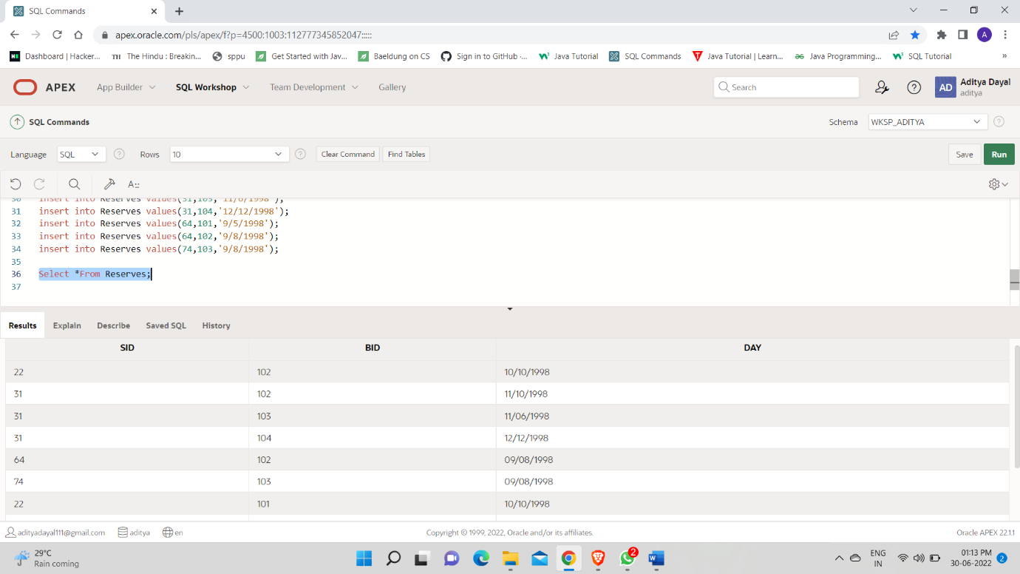

2.

select sname, age from Sailor1;

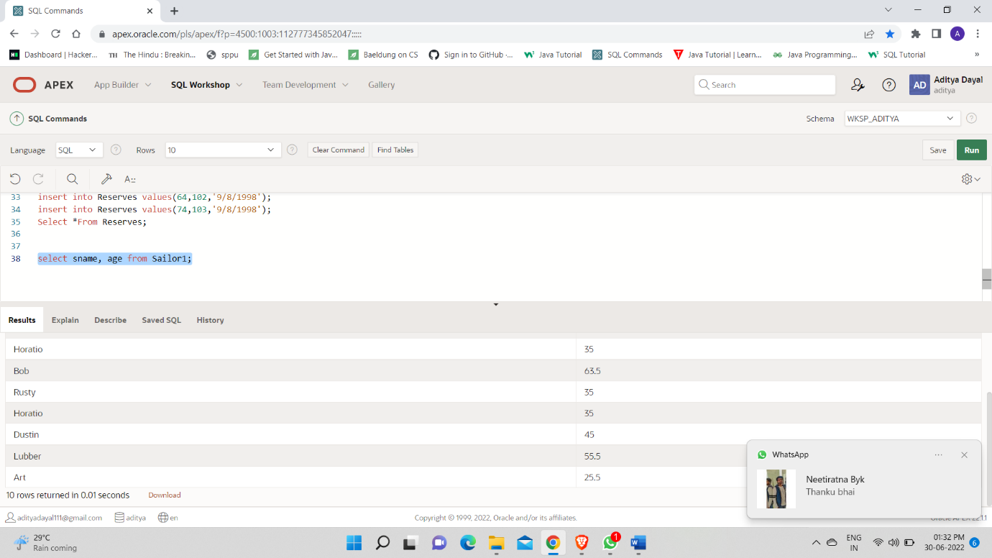

3.

Select sname,rating from Sailor1 where rating>7;

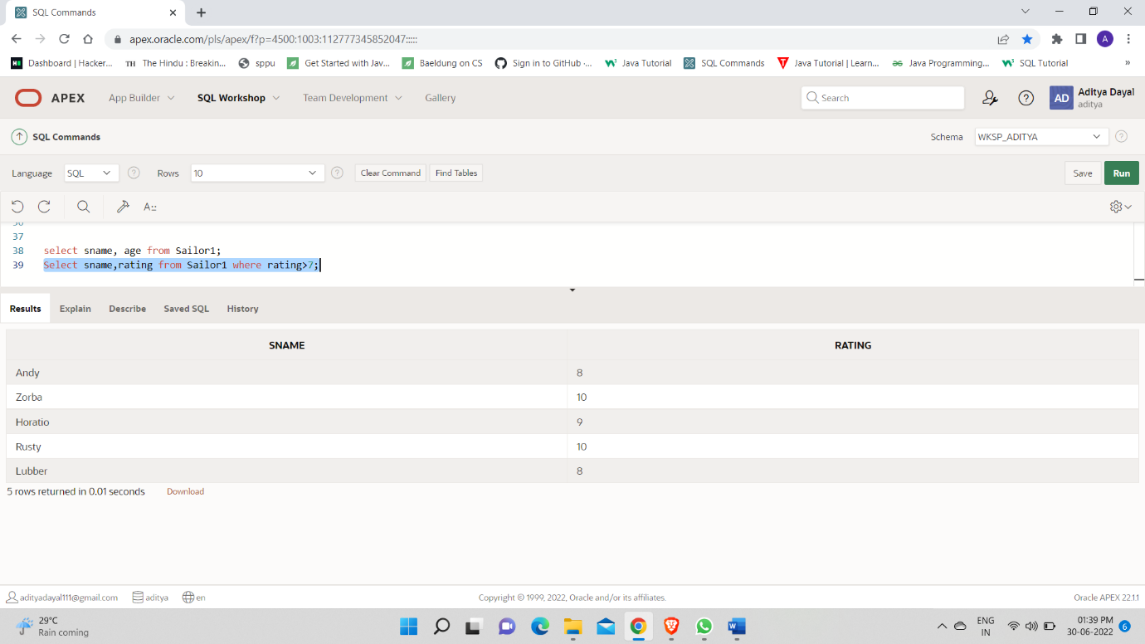

4.

update Sailor1 set rating =rating+rating*0.1 where age<40 ;

select * from sailor1;

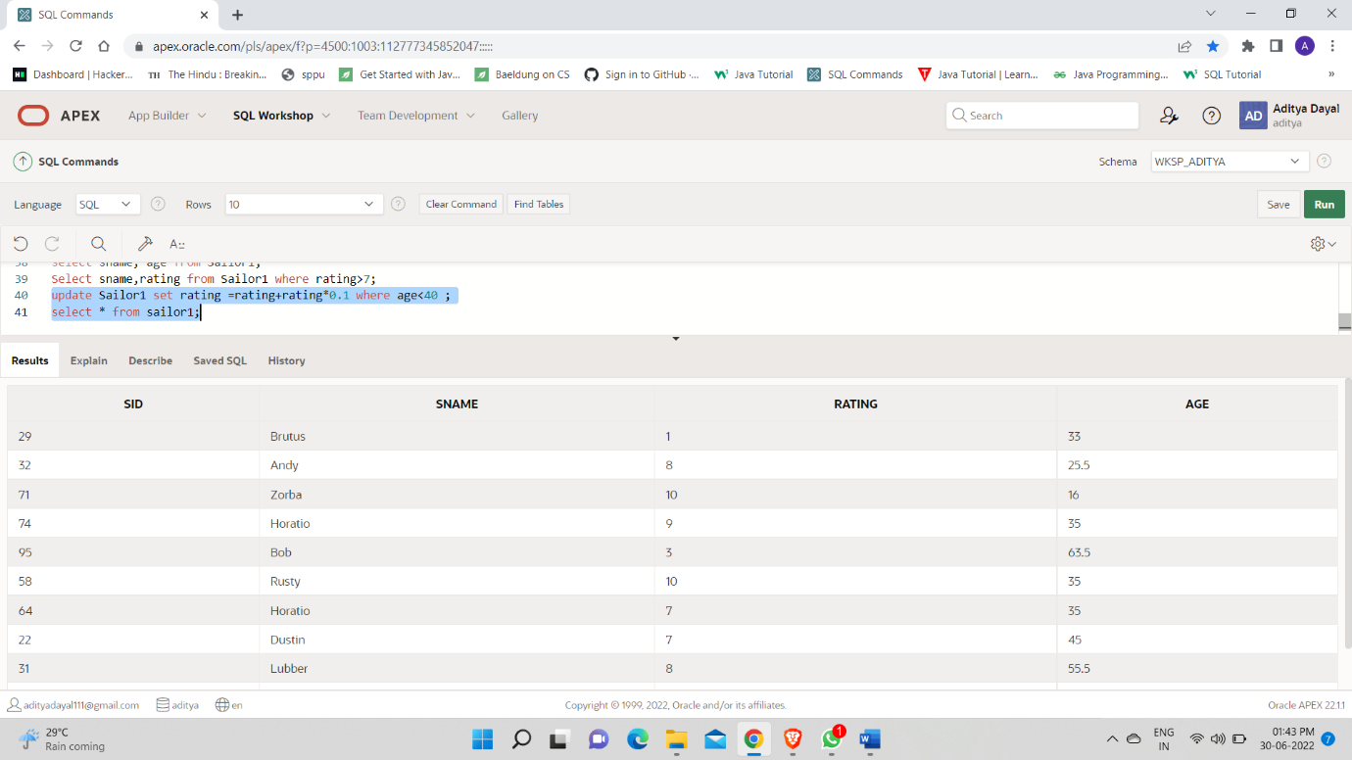

5.

update Sailor1 Set rating=rating+2 where Sid in(Select Sid from Reserves where day='11/12/1998');

Select *From Sailor1;

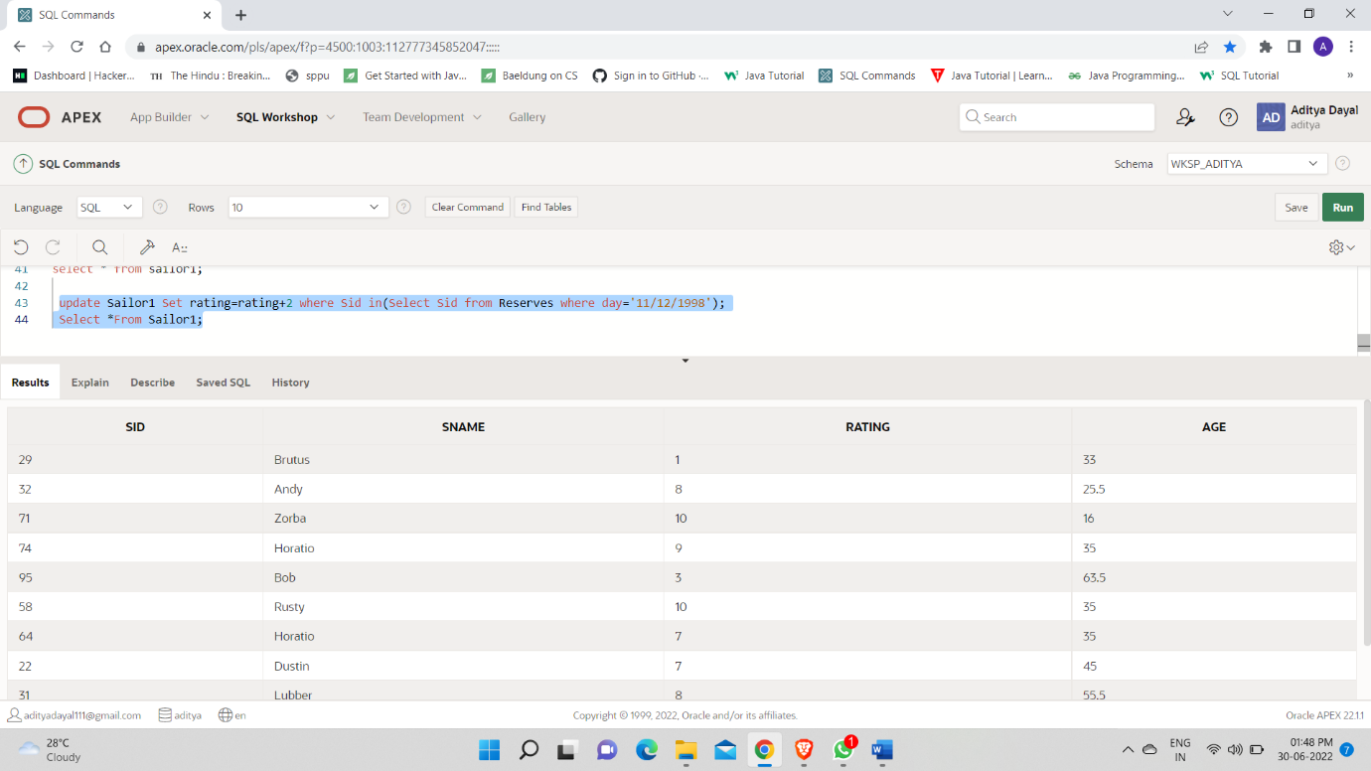

6.

delete from Sailor1 where (rating<3 and age>60);

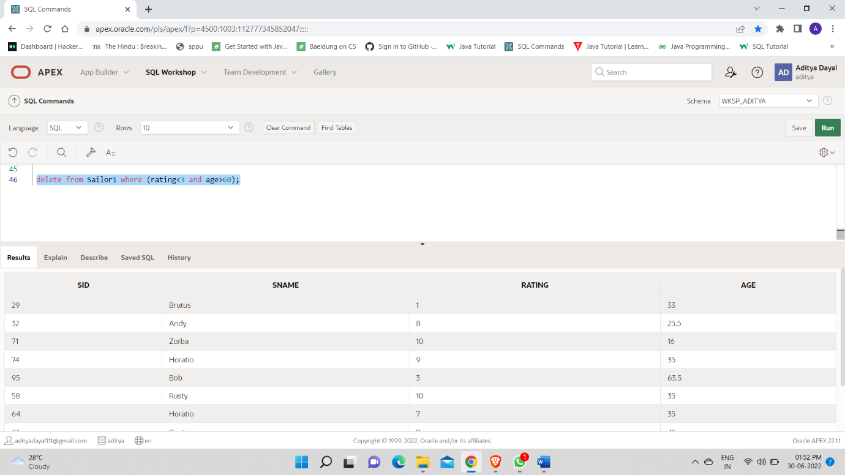

7.

delete from Sailor where sid in (select sid from Reserves where bid =102);

